| Unit 10 Python GUI Problems [Learning Plan Index - Python](https://docs.google.com/document/d/1B5yWb6wCSRhqD42iWxCi7bmLPY2EqvU6pbiEQT0zs20/edit?usp=sharing)    *Unit 10 of Python Programming - Unit 10 Problems Python* | |
| --- | --- |
| Learning Targets  This unit we will…  Explore GUI programming and the basic window, the Canvas, and the different actions we can program for.  I can…   * Create a GUI window and a Canvas Window with Tkinter. * Pack or Grid different elements into a GUI object. * Create GUI windows in class files and associate methods with different GUI objects. * Use the move and after methods of the Canvas class to create animations. * Bind button clicks to a window so that programmed actions can happen on a click.   Vocabulary: GUI, pack, grid, class, method, event binding, Tkinter, labels, buttons, window, Canvas, animation, widgets, frames, widget variables, menus, scrollbars, dialog boxes. | |
| Learn About It!  *You can explore some, or all of these resources. If you want to see a resource again, go for it!*  [Learning Plan Index - Python](https://docs.google.com/document/d/1B5yWb6wCSRhqD42iWxCi7bmLPY2EqvU6pbiEQT0zs20/edit?usp=sharing) *These Collab documents review the concepts of each unit with code you can run and modify.* | |
| Evidence of Learning  *Complete the following programming exercises.*  [Grading Rubric](https://docs.google.com/document/d/1shjqolaw_5tSX9T5OJ2FZuBeon7K3hDrYEJ5m1ltSEw/edit?usp=sharing) | |
| Unit Programs  Review:   1. [10P - 01 - Unit 10 GUI - Graphical User Interface with Tkinter](https://docs.google.com/document/d/1pk_oMXLYP9qt2_HDl49-dHFtxJqAdpoFXkKuwQQmGHQ/edit?usp=sharing)   Once you have reviewed the GUI Google Doc overview , complete the problems below. There are tips, sample code, and links to sample code that you will use within the overview document, you also may want to refer back to early colabs. You can [fork this repl.it that has the subfiles for each GUI already created for you](https://replit.com/@MrReynolds/Unit10StudentStart#main.py) as well having all the code you need completed in the Main.py file. Once you have forked the repl.it get the share link and add it to the classroom assignment. If you work in pycharm you should create a subfolder, put your last name in the folder name, to hold all your subfiles that will hold the classes that you create your GUIs with. Pycharm users when you are done you will zip your folder with all the files in it and turn in that zipped folder.  **ALL GUI WINDOWS HAVE TO BE CREATED WITH CLASSES**  **Unit 10 Problems**  **Sample output is shown below**   1. **Move the Ball** - (20 points) -  Write a program that moves a ball on a Canvas. You should define a BallButtons class for displaying the ball and provide the methods for moving the ball left, right, up, and down, as shown in figure below. Check the boundaries to prevent the ball from moving out of sight completely. 2. **Create an investment-value calculator** - (20 points) -  Write a program that calculates the future value of an investment at a given interest rate for a specified number of years. The formula for the calculation is as follows:   futureValue = investmentAmount * (1 + monthlyInterestRate)years * 12  Use text fields for users to enter the investment amount, years, and interest rate. Display the future amount in a text field when the user clicks the Calculate button, as shown in figure below. 3. **Display the mouse position** - (20 points) -  Write a program: That displays the X & Y values of the mouse’s position when the mouse clicks the Canvas window. When the mouse is clicked on a new position the old position should go away and the new position should be displayed on the screen where the mouse was clicked. A sample is below. 4. **Moving Fan** - (20 points) -  Write a program that displays a fan running. This is an animation program so the fan should appear to spin. The image below is a still image of what the fan should look like when it is not spinning, but the fan should spin continuously once the program has been run. 5. **Racing Car** - (20 points) -  Write a program that simulates car racing, as shown in figures below. The car moves from left to right. When it reaches the right end, it restarts from the left and continues the same process. Let the user increase and decrease the car’s speed by pressing the Up and Down arrow keys.   Make sure you have a comment block at the top of your program with your name, the date and a list of the programs that are being run in the program. Also make sure to comment your variables, control structures, and each problem. Also use white space between the problems.  ############################################################  # Name : Date: #  # Unit 10 Problems #  # Moving Ball GUI, Loan Calculator GUI, #  # Mouse Position GUI, Animated Fan GUI, #  # Racing Car GUI #  ############################################################  When your code works and is commented on, turn it into the classroom. | |

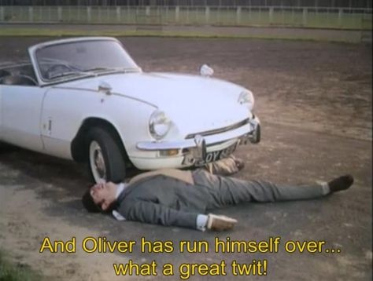

Do not run yourself over with your race car!!